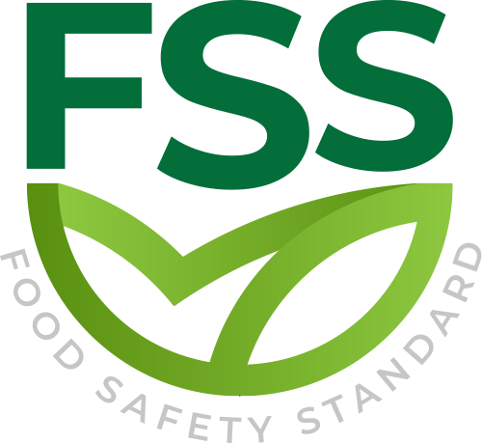

OWERVIEW STANDARD

Document Code _ FSS-STD-002
Approval Date : 20.02.2020

Title: Food Safety Standard (FSS)
Contact Adress : Merkez Mahallesi Dr Sadık Ahmet Cd, No 38/44 A Bağcılar/İstanbul – Türkiye / Turkey
Contact Mail: info@foodcertificate.org
Website: www.foodcertificate.org
Phone: +90 212 702 40 00

ABOUT US
The Food Safety System (FSS) certification program developed by our organization is a system for the inspection and evaluation of food safety and quality according to accepted standards. The certification program in question not only ensures food safety, but also undertakes responsibilities such as public health and environmental protection. This certification program is recognized as the most important initiative of recent years for a more effective and quality food management.

While developing the Food Safety System (FSS) certification program, our organization followed a global food safety strategy and adopted a safer food policy to be healthier. According to this strategy, preventing foodborne diseases and ensuring food safety require holistic, risk-based and timely food safety policies and strategies.

Our organization continuously improves its effectiveness by participating in the efforts for the development and implementation of the food management system in enterprises. It supports businesses in the food industry to meet legal and regulatory requirements, tries to establish a quality policy in businesses, supports businesses in establishing food safety targets, directs management reviews and tries to ensure the correct and effective availability of resources. In all these works, our organization approaches businesses in an impartial and independent manner and does not enter into any conflict of interest.

Our organization acts with a sense of responsibility in order to be with people who care about their nutrition and to help them make safe food choices. In this context, it provides Food Safety System (FSS) certification services to support companies that produce, store, distribute and prepare food in order to prove their efforts in this direction.

- OBJECTIVE
A.1 The Diagram
The FSS certification program outlines the audit and certification requirements for the food safety management system (FSMS) and quality management system (QMS) of organizations in the food supply chain. This certificate confirms that the organization's FSS or food safety management system (FSMS) and quality management system (QMS) meet the requirements of the scheme.
- Additional FSS requirements determined by our stakeholders
- ISO 9001:2015 requirements
- ISO 22000:2018 requirements for any organization in the food chain
The purpose of the plan is to ensure that it continues to meet the requirements of the international food industry, thereby obtaining certification and ensuring that the organization provides safe food to its customers.

A.2 Ownership and Governance
The FSS Foundation retains the ownership and copyright of all project-related documents, and holds agreements with all relevant certification agencies, accreditation agencies, and training institutions.

- SCOPE
The plan aims to audit, certify and register organizations in the following food chain categories.
Category | Description
FSS-01 | Biochemical product production
FSS-02 | Production of food packaging and packaging materials.
FSS-03 | Provide transportation and storage services for environmentally stable food, feed and packaging materials.
FSS-04 | Provide transportation and storage services for perishable food and feed.
FSS-05 | Retail /Wholesale
FSS-06 | Catering
FSS-07 | Production of pet food (for other pets).
FSS-08 | Production of pet food (only for dogs and cats).
FSS-09 | Feed production
FSS-10 | Processing of stable products at room temperature
FSS-11 | Processing of perishable animal and plant products (mixed products)
FSS-12 | Processing of perishable plant products
FSS-13 | Processing of perishable animal products
FSS-14 | Fish and seafood farming
FSS-15 | Animal breeding with meat/milk/egg/honey as raw materials

B.1 CATEGORY ( FSS-01…15)
B.1.1 The food chain subcategory AI refers to raising livestock on land for human consumption. Does not include activities such as hunting or trapping.
B.1.2 Food chain category FSS involves the following food processing activities:

- Processing of perishable animal products. Production of animal products, including fish and seafood, meat, eggs, dairy products and fish products.

- Processing of perishable plant products. Production of plant products, including fresh fruits and fresh juices, vegetables, grains, nuts and beans, frozen water-based products (such as ice).

- Processing of perishable animal and plant products. Produce mixed plant and animal products, including pizza, lasagna, sandwiches, dumplings, and ready-to-eat meals.

- Processing of environmentally stable products. Production of food stored and sold at ambient temperature from any source, including canned food, biscuits, bread, snacks, oil, drinking water, beverages, pasta, flour, sugar, and food-grade salt.

B.1.3 Food chain category FSS covers the production of animal feed and pet food:
a) Produce feed from single or mixed food sources for food animals.

b) Production of pet food (only for dogs and cats). Produce feed from single or mixed
food sources for non-food animals.

c) Production of pet food (for other pets).

B.1.4 Food chain category FSS is applicable to the provision of catering services to consumers. Food is prepared at the place of consumption or satellite unit.

B.1.5 Food chain category FSS applies to retail and wholesale activities.

B.1.6 Food chain category FFS is applicable to third-party logistics service providers who actually store and/or transport food, feed, or food/feed packaging materials, regardless of their legal product ownership. It may include other activities, such as repackaging products, freezing and thawing activities.

B.1.7 The packaging covered by Food Chain Category FSS includes the production of food/feed packaging, food/feed packaging materials and intermediate products, which are used for:
a) Direct food contact surfaces or materials that will come into contact with food during the normal use of food packaging and/or food packaging (ie, body contact with food or contact with headspace);

b) Indirect contact with food surfaces or materials that are not in direct contact with food during the normal use of food packaging, but may transfer substances to food.

B.1.8 Food chain category FSS involves the production of biochemicals and is suitable for the production of food and feed additives, vitamins, minerals, biological cultures, flavors, enzymes and processing aids, but does not include pesticides, drugs, fertilizers and detergents .

C.FSS QUALITY

The FSS quality certification is a voluntary supplement to the FSS certification requirements and supplements these requirements with all the requirements of the ISO 9001 quality management system, resulting in the FSS certificate of the FSS quality category.

Requirements for quality development, implementation and maintenance
The management system is specified in the ISO 9001 "Quality Management System Requirements" standard.

